Marie Chauke
ST10494165 SELF EVALUATION
WIL POE
SELF EVALUATION

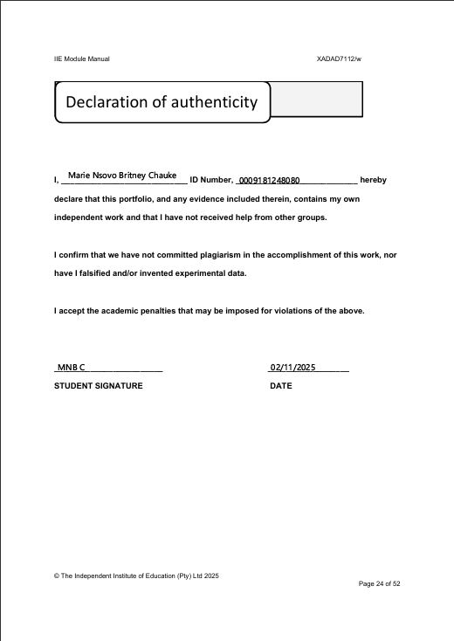

Self-Evaluation Report – Business Analyst
Name: Marie Nsovo Britney Chauke
Role: Business Analyst
Project: Ungana Connect
Period: July – October 2025

Introduction
During my WIL experience as a Business Analyst on the Ungana Connect project, I gained a deeper understanding of how structured workplace learning bridges academic theory with practical application. The purpose of WIL is to expose students to real-world challenges, team dynamics, and professional expectations. I found it invaluable for developing both technical and interpersonal competencies, while contributing meaningfully to a civic technology initiative.

Skills Learnt

🛠 Industry-Specific Practices
- Conducted stakeholder interviews and requirement-gathering sessions
- Created user personas and journey maps to guide development priorities
- Documented functional specifications and acceptance criteria for modules such as issue reporting and event announcements
- Facilitated feedback loops between users and developers to refine features

🗣 Interpersonal Communication Skills
- Participated in weekly team meetings and sprint reviews
- Presented findings and recommendations to the project manager and developers
- Collaborated with cross-functional team members to resolve scope ambiguities
- Handled feedback constructively and adapted documentation accordingly

⏱ Time Management Skills
- Prioritized tasks to meet sprint deadlines and client review schedules
- Managed overlapping responsibilities across documentation, testing, and feedback analysis
- Responded to unexpected changes in scope by adjusting timelines and deliverables
- Maintained version control and traceability in documentation to support agile workflows

Role in the Team
As the Business Analyst, I reported directly to Zoleka (Project Manager) and worked closely with developers Bhekile and Terrence, as well as Neo (Database Administrator). My role was central to translating stakeholder needs into actionable development tasks.
- I took initiative in leading requirement workshops and clarifying user expectations
- My documentation enabled smoother development handoffs and reduced rework
- I contributed to team success by ensuring alignment between user needs and technical feasibility
- I helped mediate scope concerns and facilitated resolution of feedback-related conflicts
- The team dynamic was collaborative, with mutual respect and open communication

Research, Technology and Presentation of Information
I used a combination of academic and industry sources to validate user engagement strategies and civic tech best practices. Tools such as Microsoft Word, Excel, and Lucidchart supported my documentation and visualization efforts. I ensured that all information presented was relevant, accessible, and tailored to stakeholder expectations. My reports were structured, referenced (Harvard style), and aligned with project goals.

